**Default Icons used in Mockup**

“Budget - pie chart 2”

/Users/superchris/Desktop/Screen Shot 2017-10-17 at 17.29.45.png

“Goals - action flag”

/Users/superchris/Desktop/Screen Shot 2017-10-17 at 17.31.12.png

“Overview - graphs”

/Users/superchris/Desktop/Screen Shot 2017-10-17 at 17.31.22.png

“Transactions - action credit card”

/Users/superchris/Desktop/Screen Shot 2017-10-17 at 17.31.40.png

“Checklist checks beside list”

/Users/superchris/Desktop/Screen Shot 2017-10-17 at 17.31.04.png

**Default look of Tab Bar**

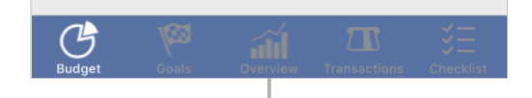

General Look:

